Azure Setup & .NET API Foundations
Hands-on:
- Deploy to Azure App Service
- Understanding App Service Plans
- Working with Deployment Slots
API Management & Security
- Azure API Management (APIM)
What is an API Gateway?
An Api Gateway is a runtime component that acts as a single-entry point for all client requests to backend services.
Instead of client calling multiple services directly, they communicate with the API Gateway, which routes requests to the appropriate service.

Simple Architecture

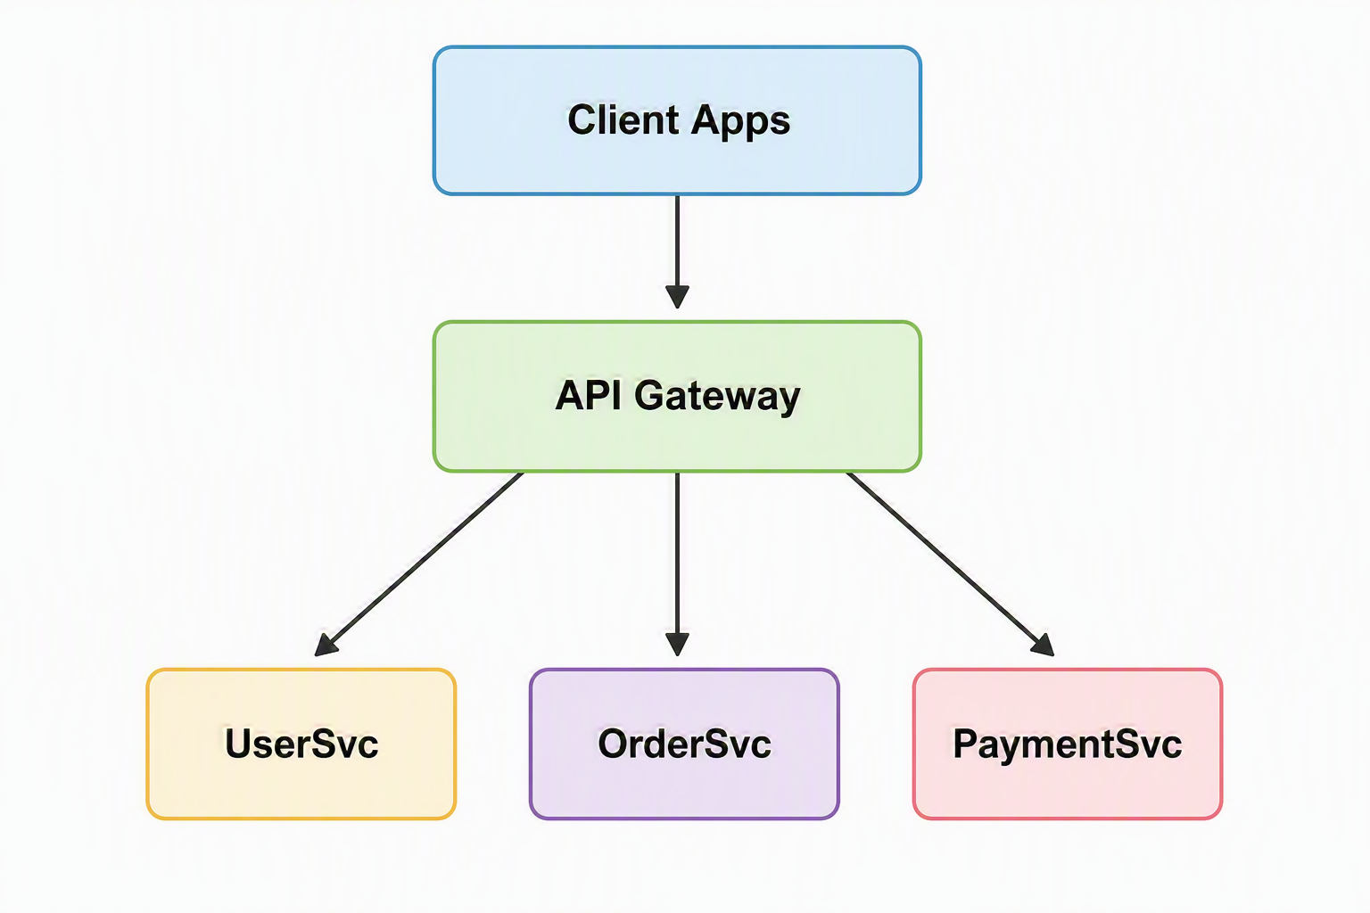
Key responsibilities of an API Gateway
- Request Routing
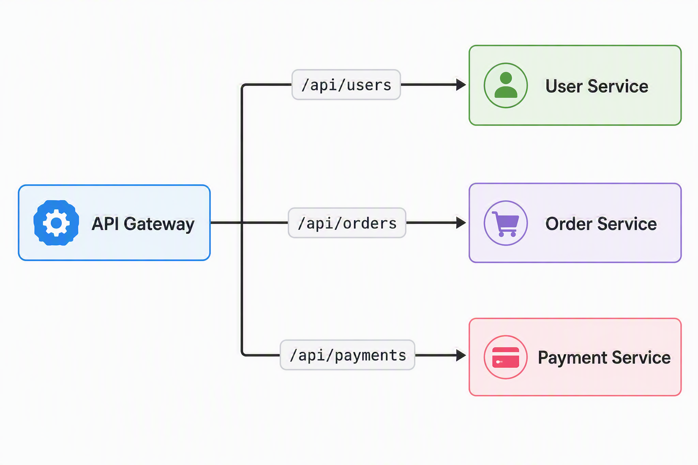
- Authentication & Authorization
Common methods:
    - JWT Tokens
    - OAuth 2.0
    - OpenID Connect
    - API Keys
    - Client Certificates
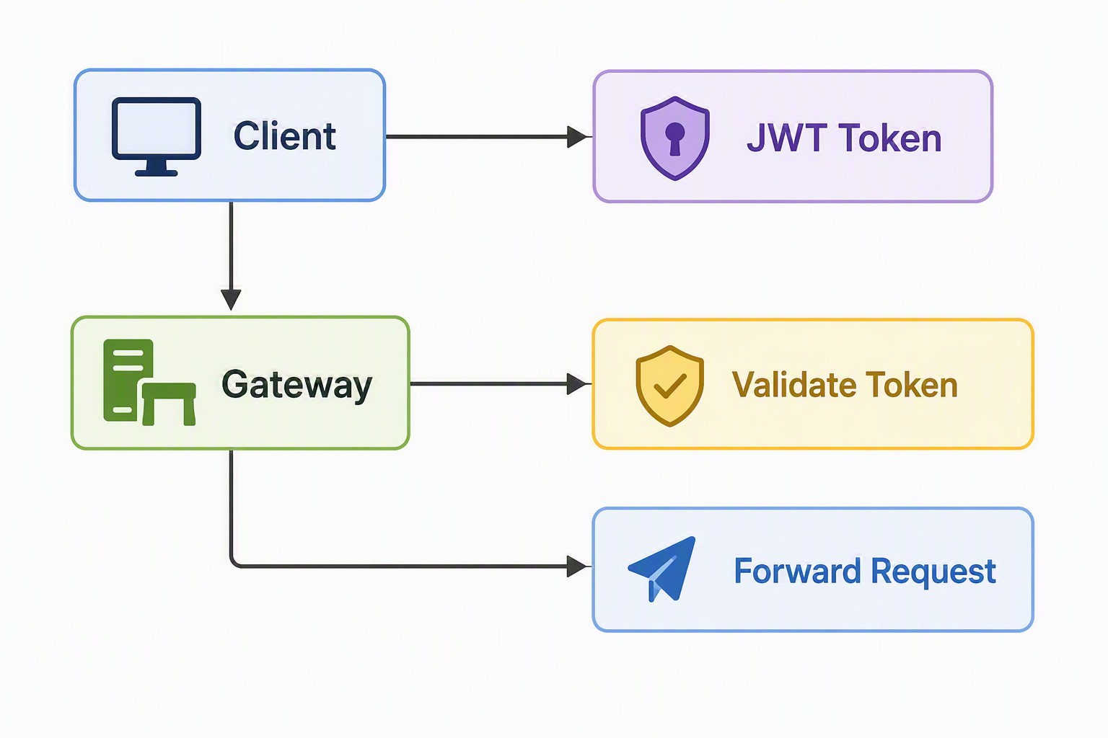
- Rate Limiting
- Load Balancing
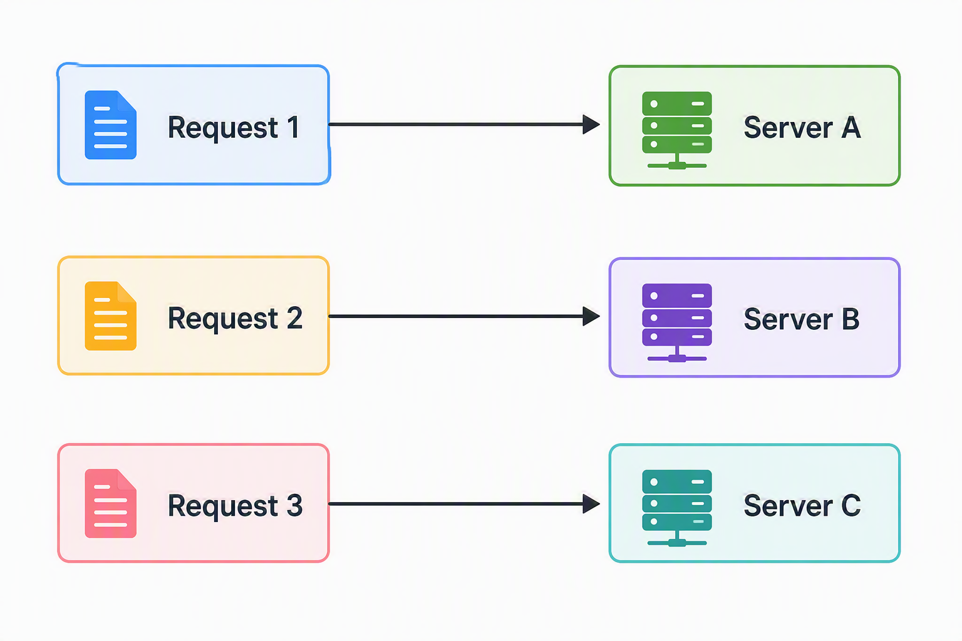
- Request/Response Transformation
- SSL/TLS Termination
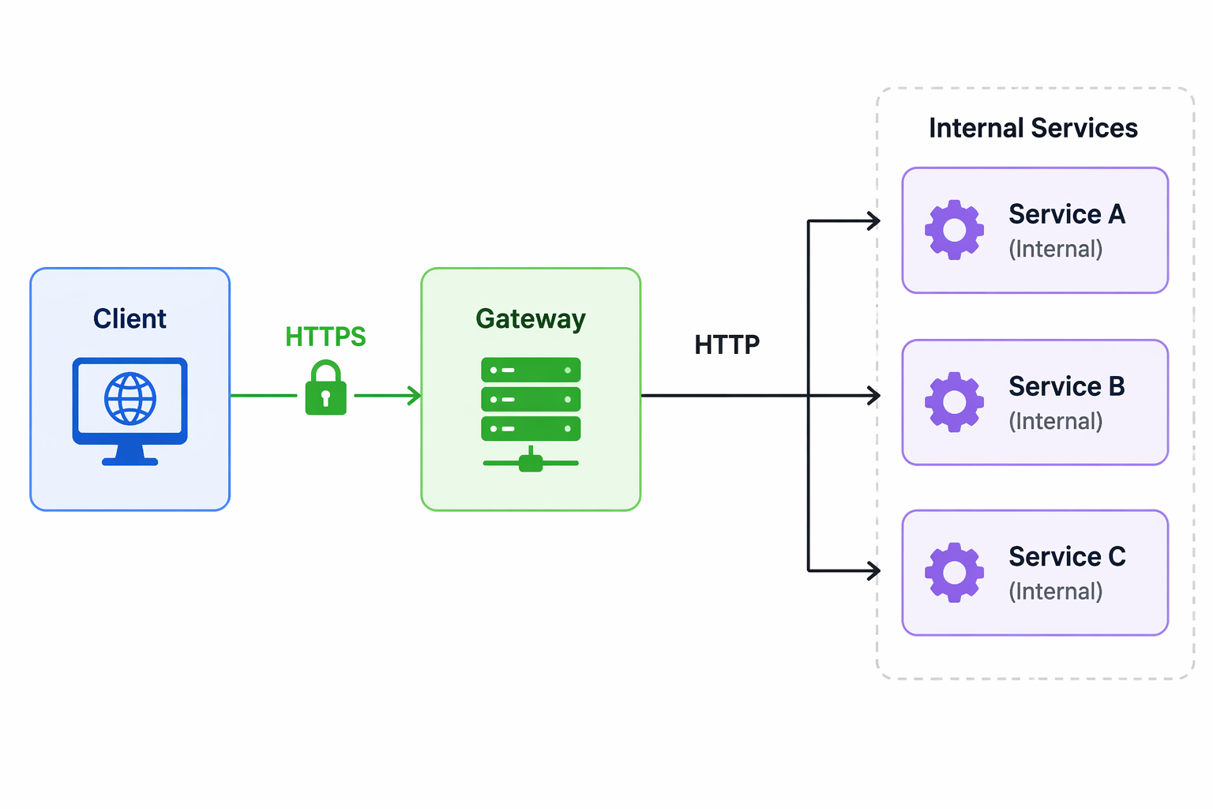
- Caching
- Monitoring & Logging
Tracks:
    - Request Count
    - Latency
    - Error Rates
    - Service Health
- API Aggregation
Without Gateway
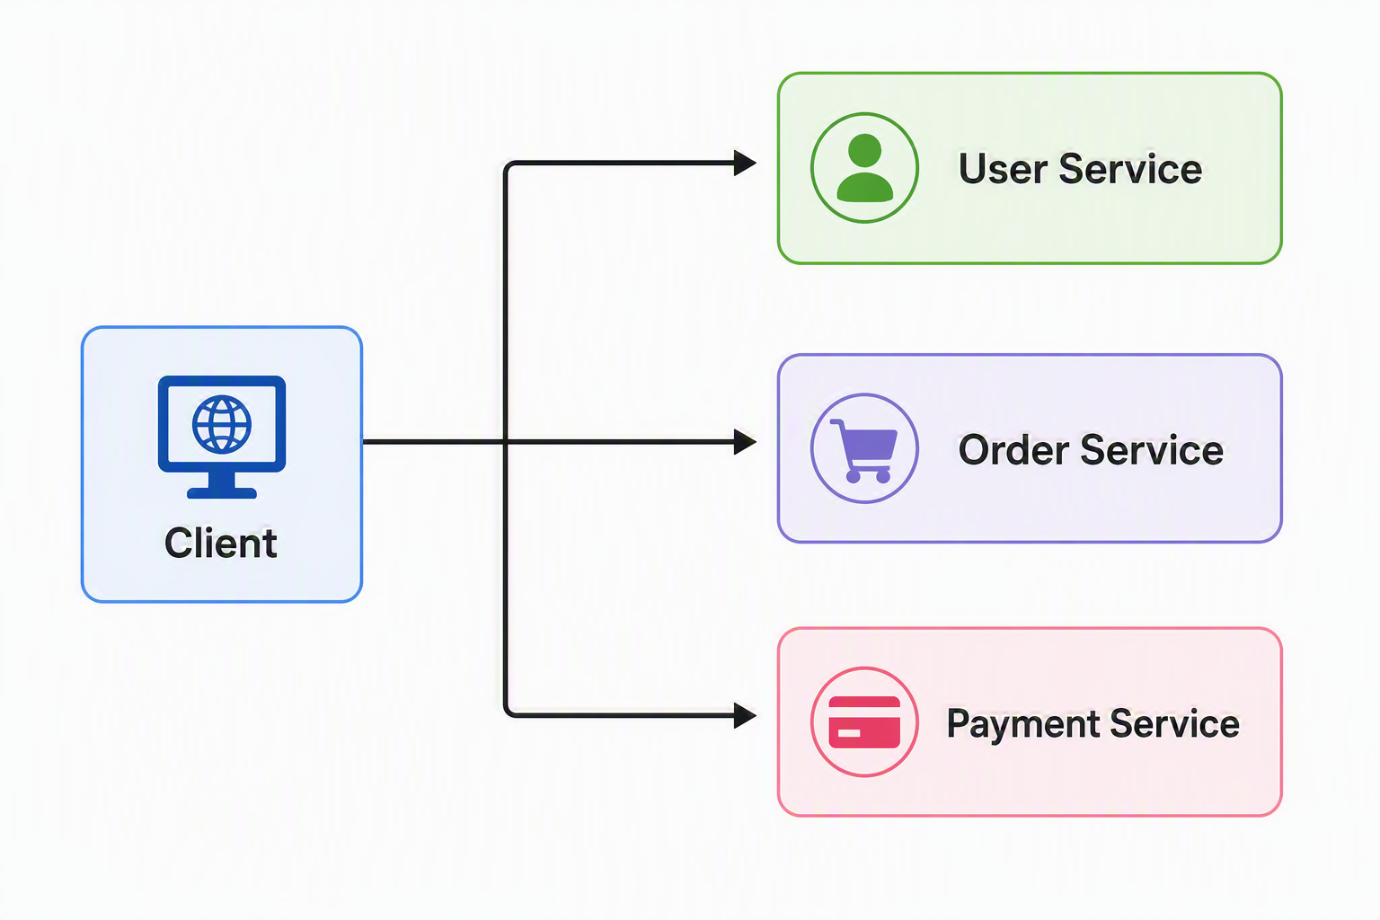
With Gateway
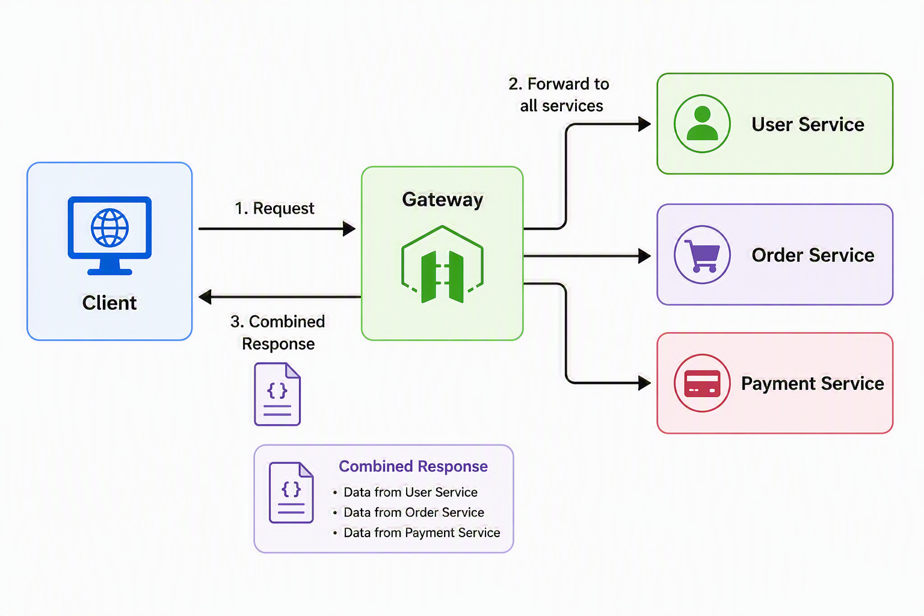
Popular API Gateway Products
  - Cloud Providers
    - Azure APIM Gateway
    - AWS API Gateway
    - Google API Gateway
  - Open Source
    - Kong Gateway
    - NGINX API Gateway
    - Apache APISIX
    - Envoy Proxy
    - Traefik
    - Ocelot API Gatway(.NET)

